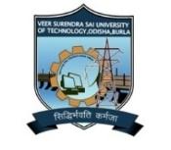
VEER SURENDRA SAI UNIVERSITY OF TECHNOLOGY BURLA
(A UGC Recognized State Government University by an Act of Assembly, Estd. -1956)
P.O. Engineering College, Burla, Dist: Sambalpur, Odisha, (India) -768 018
www.vssut.ac.in. e-mail: vc@vssut.ac.in

Attainment of Course Outcomes (COs)-Indirect Assessment
Please rate yourself in the scale of 0-3 (0-Not Acquired, 1-Low, 2-Medium, 3-High) on acquiring the below mentioned capabilities after completion of the following subject.
Academic Year :
Subject Name :

# | Course Outcomes
CO1
CO2
CO3
CO4
CO5

Regd. No. | CO1 | CO2 | CO3 | CO4 | CO5
Average Score

Signature of Course Instructor

